How to Convert a VHD to VMDK VM Image

**Note:** This conversion process is not supported by ASKIBM Support.

**Step 1:** Install and run **WinImage**. (<http://www.winimage.com/download.htm>)

**Step 2:** Go to **Disk** in the menu bar and select **Convert Virtual Hard Disk Image**.

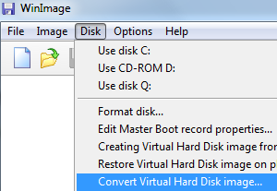

**Step 3:** An “Open” dialog box will show up. Make sure that the file type selected is **Virtual Hard Disk (*.vhd)** which should be default selection. Browse to the folder location for the VHD file, select to highlight the VHD, and then click **Open**.

VHD Conversion Source

**Step 4:** Select either **Create Fixed Size Virtual Hard Disk** or **Create Dynamically Expanding Virtual Hard Disk**. You should choose the later for more flexibility if you foresee there will extensive usage on the disk image.

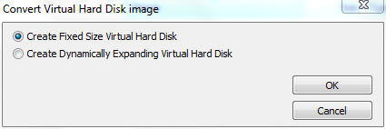

**Step 5:** On the “Save As” dialog box, change the output format under the **Save as Type** to **VMWare VMDK (*.vmdk)**. Browse to the folder location which the output disk image to be saved and enter a file name (no extension required). When done, click **‘Save’.**

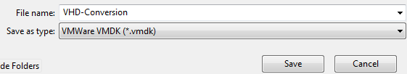

**Step 6:** WinImage will start the virtual hard disk image conversion process, which may take a while to complete, depending on the size of the virtual hard disk.

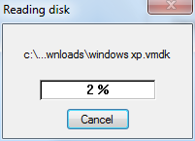

**Step 7:** Once the conversion is done, the VMDK virtual disk is ready for use. WinImage will try to mount the converted virtual disk image in the program after the conversion, where it asks user to select the partition to connect to.

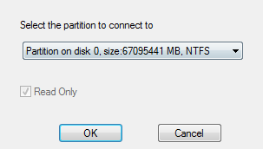

Click **OK** if you want to open the virtual disk in WinImage, or **Cancel** to return to main program.

**Step 8:** To finalize your VM after the conversion process, please click on the following link.

|  |
| --- |
| <https://kb.vmware.com/selfservice/microsites/search.do?language=en_US&cmd=displayKC&externalId=2010196> |